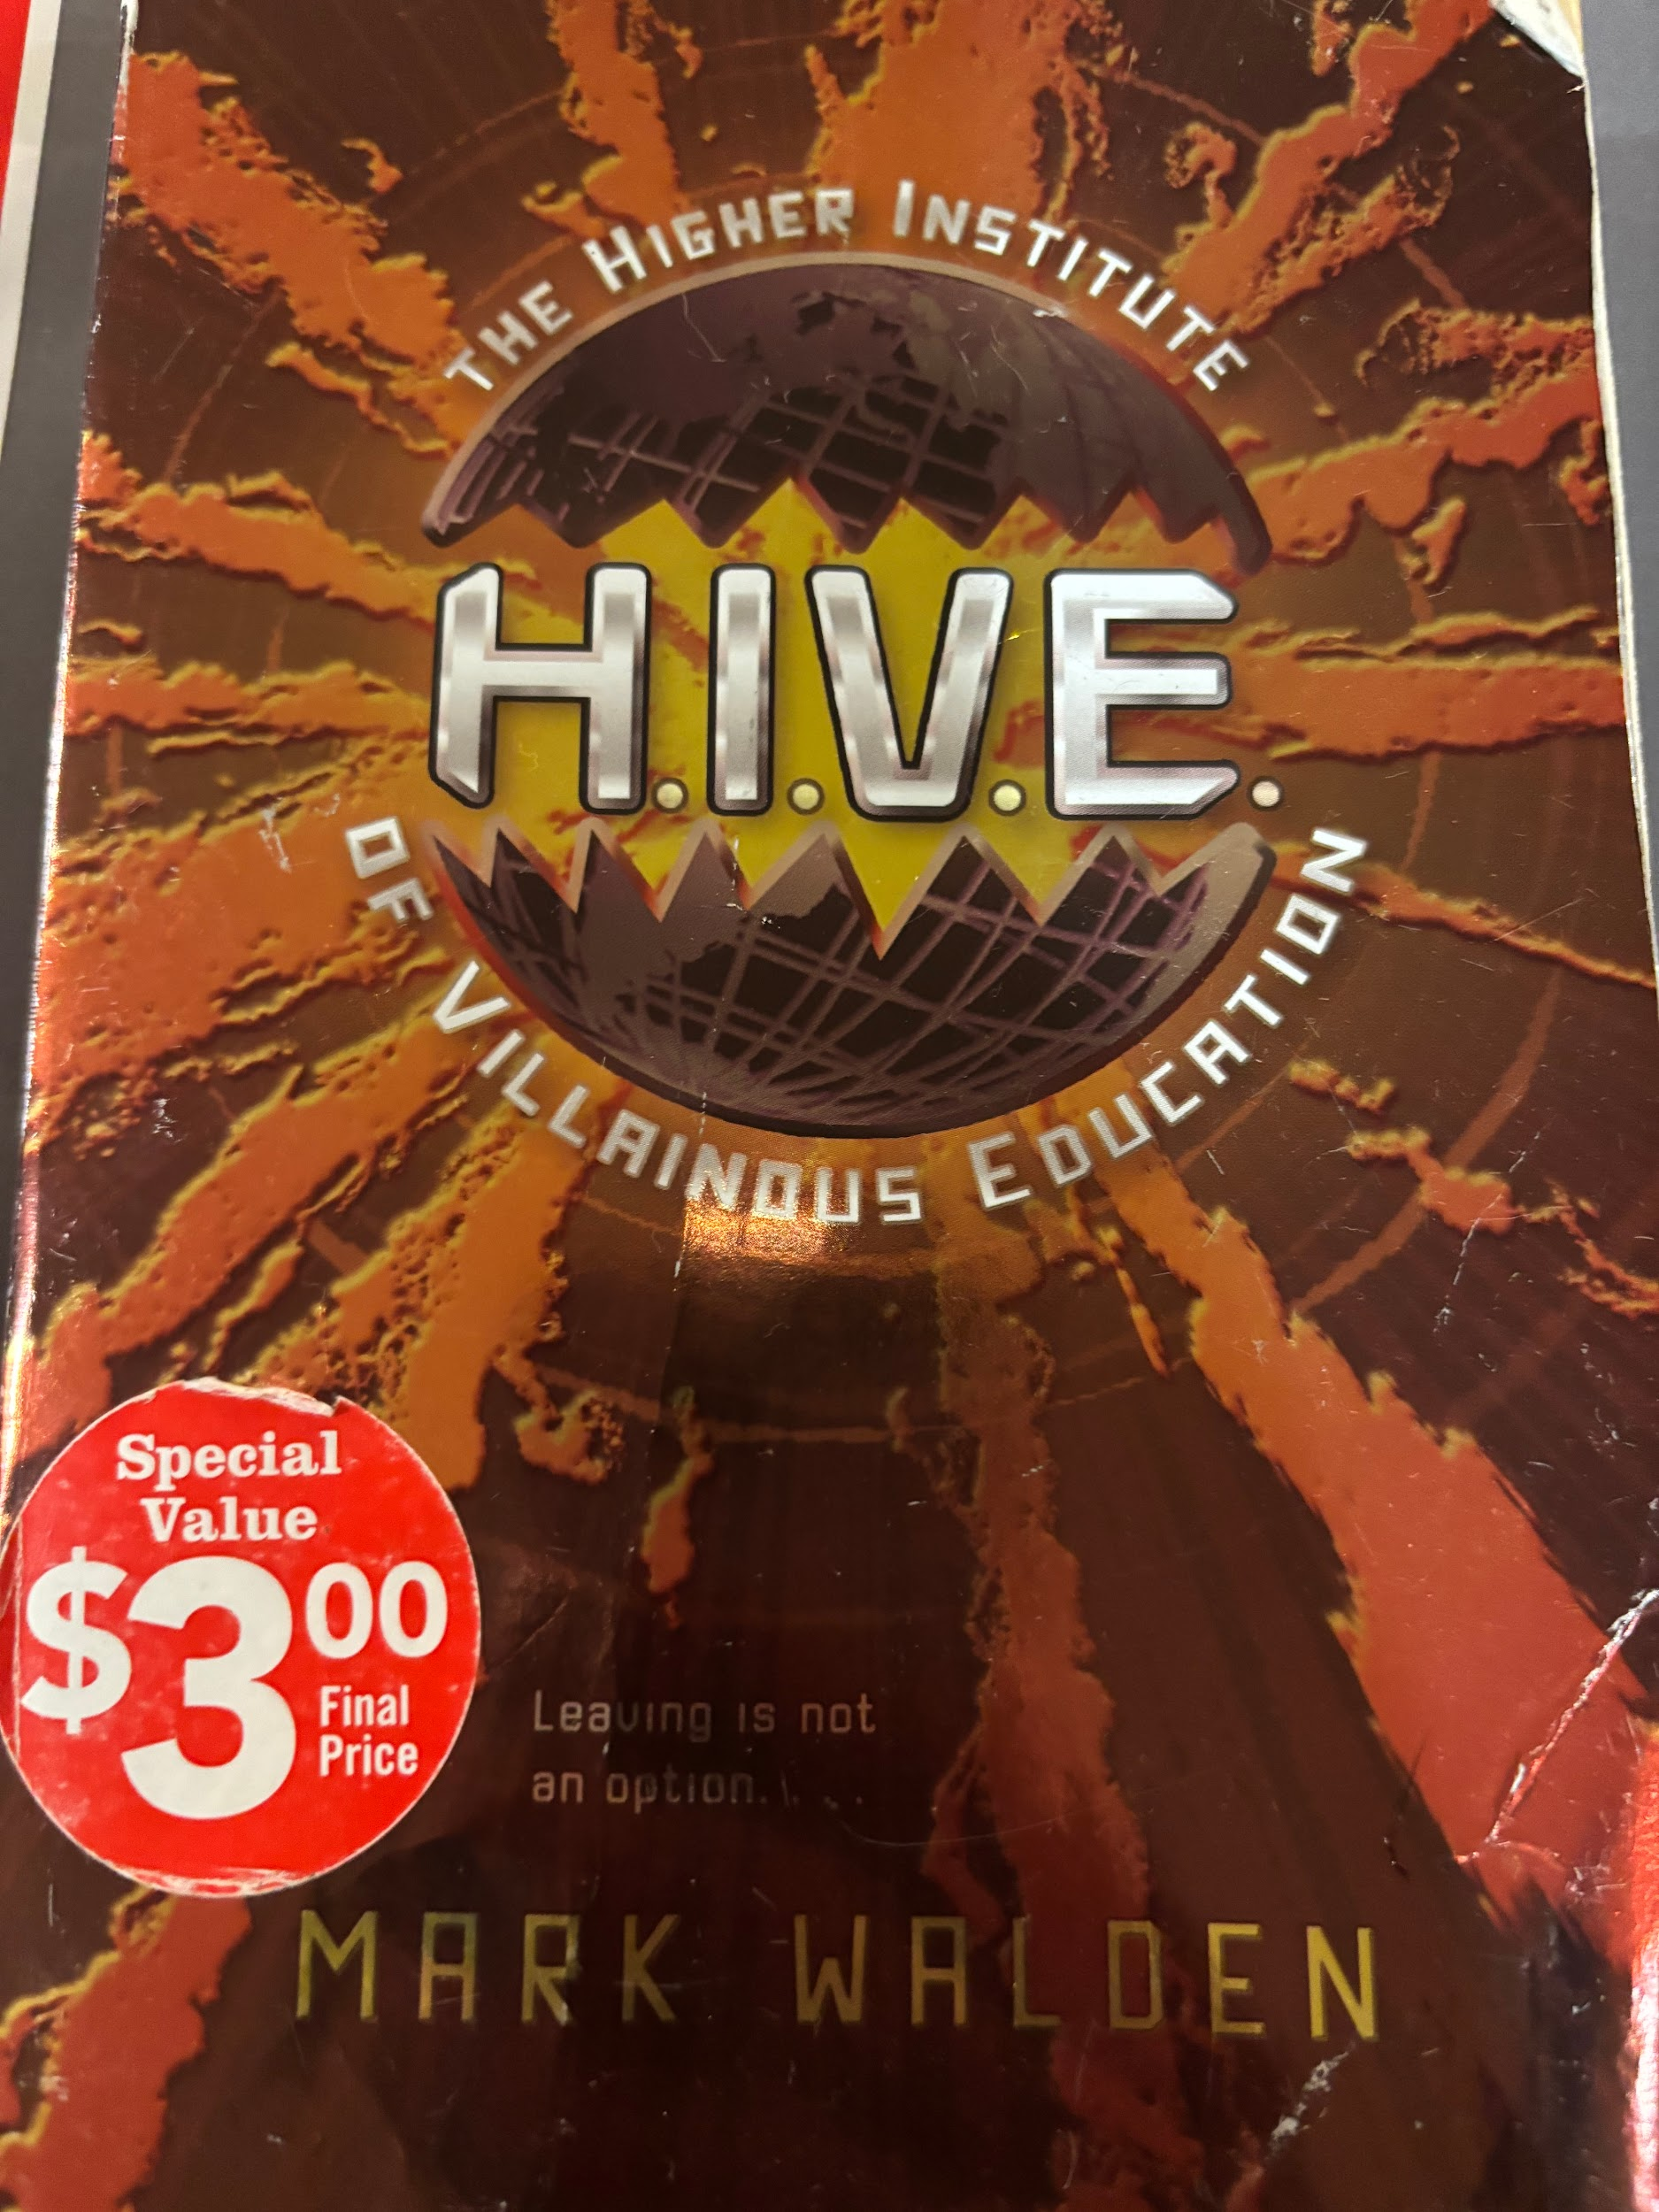

H.I.V.E.

Book Author: Mark Walden

Reviewed by: Saihba Virdi, 14

Star Book Reviewer of Be the Star You Are! Charity

[www.bethestaryouare.org](http://www.bethestaryouare.org)

This book follows the story of Otto Malpense, a teenage boy who is forcibly abducted and placed into a high security school, the Higher Institute of Villainous Education or H.I.V.E. Why was he chosen? Because he shows promising signs of being a super villain. This school has the goal of training kids to become super villains, and unleash their potential to the world. Dr. Nero, the headmaster, sees Otto as a potential future leader, and creates bigger plans for him. As Otto makes allies, and navigates the school, he uncovers an even more sinister plot. He embarks on missions with his friend Wing, a fellow student of H.I.V.E., and tries to discover the true goal of the school so he can figure out how to beat the system.

This was a very interesting book to read. It follows a similar trope to Harry Potter, with students being taken away to a boarding school, isolated from everyone else. It was 309 pages, and the words are relatively big, making it a week long read at most. It's definitely not a big commitment, but nonetheless it was pretty detailed. One thing I didn’t like so much about the book was that it starts out pretty slow, making introductions and describing the setting for about two thirds of the book, only at the end picking up the pace and becoming more action packed, which made the ending feel rushed. Otherwise the book is well written and portrays interesting characters.

I would recommend this book for preteens, mostly because of the language and complexity of the situations the characters are in. It makes for a great book to pick up at the local library, and a fun gift, as it is part of a large series of books, eight total. It's a novel with no pictures, but the story is fun on its own. I highly recommend trying it out, as it is a fast and easy book to read, and should keep most people interested.

Recommended Titles:

-Evil Genius

-The Recruit

-Stormbreaker