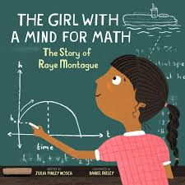
The Girl With a Mind for Math
Book Author: Julia Finley Mosca
Reviewed by: Saihba Virdi, 14
Star Book Reviewer of Be the Star You Are! Charity
www.bethestaryouare.org

Raye Montague is a smart kid, who loves math and everything science, but ends up finding out that because of the color of her skin and her gender that she will have to struggle to be recognized by anyone. She works harder than everyone else in her school to stand out, so that she can pursue her dreams. She eventually becomes a pioneer in naval engineering, who makes revolutionary ship layouts to forever change the way ships were designed on computers.

This book approaches topics of racism and sexism in an informative way, explaining how many colored people were denied diplomas in fields they excelled in because of segregated schools. Raye is not only a pioneer for naval engineering, but for the rights of women and colored people in the workforce. She is goal oriented and wants to make a difference, but at the same time be acknowledged for her contributions. I think this book was really interesting, and shone light on someone who isn’t often recognized in the STEM field despite her deep involvement in engineering.

The book is relatively short at 40 pages, with pictures and short sentences. I recommend this book for 7 year olds and above, due to some serious topics of race and gender. It is however, important to teach kids about these themes, so they can understand the immorality of discrimination, and the destructiveness of hate. This book holds an important message about the hidden figures of the past, and how they have contributed to our present. I enjoyed this book and hope you will too.

Recommended titles:
-The Doctor with an Eye for Eyes
-The Girl who Thought in Pictures
-Counting on Katherine

