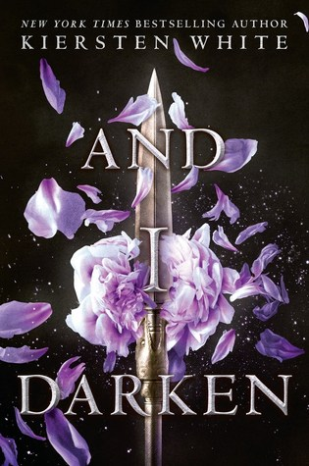
And I Darken
By Kiersten White
Reviewed by: Puneet Gill, 17
Star Book Reviewer of Be the Star You Are! Charity
www.bethestaryouare.org

This is an alternative take on the infamous Vlad the Impaler through his female reinterpretation: Lada Dragwyla. As she and her brother, Radu, live within Wallachia as the children of Vlad Dracul, they are taken under the Ottoman empire with the lavish Prince Mehmed. Lada trains with the Janissaries while Radu finds peace and converts to Islam. With political tensions between the empire and the capture of Constantinople, Lada and Radu separate on their own journeys within the walls. Mehmed grows to love Lada, yet her brother appears jealous of his intentions and causes tensions between their straining relationship. Who will Lada and Radu stay loyal to: the Ottomans—their captors, or back home with the Wallachians?

Kiersten White’s take on the vicious vaivode from present-day Romania create her dedication to research on how 15th century royal courts worked with ties to the rising Ottoman empire. Her interpretation of having a female counterpart built a more interesting take with Lada’s growing feelings for Mehmed. However, she illustrates her complex motives on remaining with Wallachia as she called the countryside her “mother” due to the beautiful nature she witnessed as a young child. Radu’s inclusion also stood out with his more passive, yet cunning, manipulation around the court not with war, but words. This switch in gender roles goes against societal expectations, especially when Sultan Murad queries Lada’s role in court, but accepts Radu as his “son” due to inferiority of women in the past.

The odd part about the novel may be the love triangle between Lada, Radu, and Mehmed. Radu likes Mehmed, but Mehmed loves Lada over the years. Yes, Radu did discover that he is into guys alongside another supporting character, meaning he is gay. However, the trope of siblings being into the same love interest may at times interfere with the wider perspective of political betrayal and truces between kingdoms and nations.

Overall, this take on historical fiction from 1400s pre-Romania and Turkey can intrigue history fans wondering about European and Middle Eastern history. Fans of Dracula, the infamous vampire, may delve into the inspiration behind his vicious nature with a female protagonist. It can be great as a library quick-pick to dive into other historical fiction books that encompass around the rise and fall of the Ottomans’ influence. The audience is best fit for ages 14 and up due to violence—including impaling heads on spikes (a common trait between Vlad and Lada), and sexuality with mentions of harems and sexual orientation.

Recommended Titles:
Now I Rise, by Kiersten White
Anno Dracula, by Kim Newman
The Ninth Rain, by Jen Williams
The Fall of the Ottomans, by Eugene Rogan
Flame in the Mist, by Renée Ahdieh

