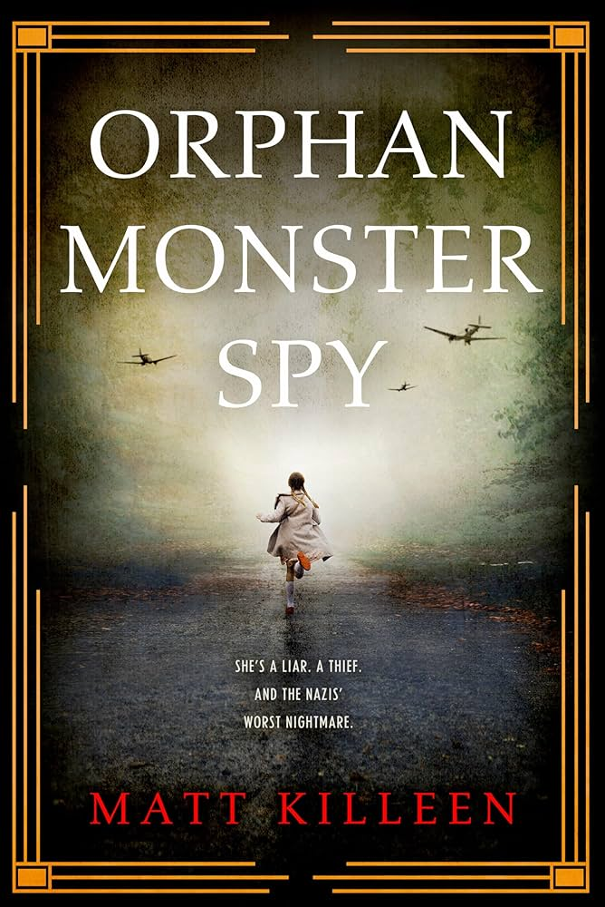
Orphan Monster Spy
Book Author: Matt Killeen
Reviewed by: Saihba Virdi, 14
Star Book Reviewer of Be the Star You Are! Charity
www.bethestaryouare.org

Orphan Monster Spy is a historical fiction novel set in 1939 Nazi Germany. It follows the life of a 15 year old jewish girl named Sarah, who finds herself orphaned after her mom is shot down at a checkpoint. She tries to hide as best she can, but is found by a British spy who decides to employ her to infiltrate a school for the top Nazi officials' daughters. But how can she do this? Because she looks exactly like the perfect Aryan girl, with blue eyes and blond hair. This book focuses on her time navigating through the school, finding bullies and allies, and attempting to befriend the daughter of a scientist who is building a bomb for the Nazis.

This book is very well written, and while being informative of what actual Nazis were doing at the time, still follows a good story line that is interesting to read. Matt Killeen doesn’t shy away from being brutally honest, and highlighting the terrible parts of all of the characters. This book showcases moral ambiguity at its finest, where characters find themselves making decisions that have the power to hurt innocents, but must be accomplished to keep themselves and their loved ones safe, or make decisions that no one can really take sides on. I appreciated the brief interactions with actual history that the characters had, and also liked that the characters, even the Nazi girls, weren’t all terrible people.

I recommend getting this at a library to see how you like historical fiction. It is 448 pages, and words are not that big, so it takes 2-3 weeks for the average middle/highschooler to finish. This is a book for 14 year olds and above, with implied assault of a minor and some graphic details about the crimes of Nazi officials. There is a sequel which is slightly darker than the first book, but if you find yourself enjoying it then Darling Devil Spy is the right book for you. In all, this was a compelling story that I think other teenagers would enjoy.

Recommended Titles:
-They Went Left
-Devil Darling Spy
-Killing November

