Kaylee Li附加了 1 个文档
 | Kaylee Li (likaylee1261@gmail.com)随信附上了以下文档：

War Games, Alan Gratz

War Games
Alan Gratz
Reviewed By: Kaylee Li, 12
Star Book Reviewer of Be the Star You Are! Charity
www.bethestaryouare.org
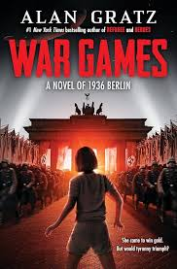
The War Games a Novel of 1936 Berlin is a fantastic novel. It is a historical book about an American gymnast, Evie Harris, who is competing for gold in the Olympics. Evie has to choose between stealing Nazi gold and following her dream of winning the Olympic Gold. I recommend it to people of about fourth to seventh graders.
There are many parts I really like about this book. One, is that it is about a girl going through some tough decisions. Another, is that Evie has a great background. She came from a poor family and escaped the Dust Bowl of Oklahoma. This really shows who Evie is which makes it really engaging and fun to read. There is nothing I do not like about this book.
This novel is captivating and gripping! Alan Gratz did a fantastic job of explaining the story and character. It really draws my attention that Evie is kind, doesn't let people put her down, and knows what is right, even if it is not at the exact moment. First, Evie tricks and leaves Heinz but as she does leave him she knew that she should not have done that and felt bad. Lastly, even though she chooses to steal the gold, in the end, she didn't take it knowing it could be dangerous.
Other books I recommend
- Alice on the Island by Alan Gratz
- Heroes by Alan Gratz
- Number the Stars by Lois Lowry

