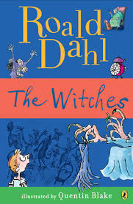
The Witches
Book Author: Roald Dahl
Reviewed by: Saihba Virdi, 14
Star Book Reviewer of Be the Star You Are! Charity
www.bethestaryouare.org

The Witches follows the story of a young kid who loses his parents in a tragic car accident. He moves in with his grandma who lives in Norway, and forms a very close bond with her. He is sure that life in Norway will be simple, but his grandma reveals to him that if he is to survive childhood he must learn about witches, and how to avoid them. He learns that Witches are cruel creatures who only have desires to kill children and do so while hiding as regular women, making them much more dangerous. He must figure out how to avoid them, and after some unfortunate incidents, he must figure out how to escape them. This story follows his battle against the Witches, and his trust in his grandma's ability to keep him safe no matter what creature he is.

This is one of my favorite books, not only because of the interesting plot, but because of how uniquely the Witches are described. This book has underlying morals, like trusting your immediate family rather than putting your hopes in strangers, and teaches the values of bravery. It is well written, with some more advanced words that will help expand most people's vocabularies, and the writing itself is both eloquent and realistic.

This is a great book for anyone 7 and above, with some themes of violence and hate. However, while the writing might seem too advanced, it is pretty easy to understand what's happening, so it's great for small kids. It’s 208 pages long with medium sized lettering, so it goes by pretty fast, and if you enjoy Roald Dahl’s writing style then there are a plethora of other books to choose from. In all, I enjoyed this book, for its engaging writing style, interesting plot, and funny drawings.

Recommended Titles:
-Frankenstein
-The Twits
-The Monkey Stones

