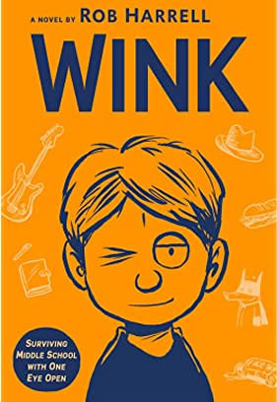
Wink
Book Author: Rob Harrell
Reviewed by: Saihba Virdi, 14
Star Book Reviewer of Be the Star You Are! Charity
www.bethestaryouare.org

Wink is a novel following the experiences of 12-year-old Ross Maloy who is diagnosed with a rare form of eye cancer. He begins to experience not only physical challenges but social ones, being called “the cancer kid”, and no longer feeling normal. He undergoes treatment for his eye as he learns to find connection to others through music and art. He makes friends with unusual characters that he wouldn’t have met if he weren’t undergoing treatment.

This was a great book, which was both informative and quite funny. I think a lot of people will enjoy both the humor and the emotional depth of the story, which the author ties together to make the plot feel organic. There is a detailed description of how radiation therapy works, and how they use different tools to keep you completely still. It is an interesting process but luckily doesn't take up the entire story.

I recommend this book for 10-year-olds and above, with heavy topics and some harsher language. No swear words or anything like that, just harsher words. It is a relatively short read despite being 313 pages long, because there are some pictures and the words are pretty big, so it will likely take around a week to finish. I highly recommend this to anyone who wants to understand more about eye cancer or just the process of treating it. It is an entertaining book, so I suggest picking it up at a library or a bookstore.

Recommended titles:
-Ugly
-Wonder
-El Deafo
-The War that Saved My Life

