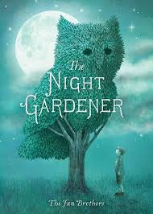
The Night Gardener
Book Author: The Fan Brothers
Reviewed by: Saihba Virdi, 14
Star Book Reviewer of Be the Star You Are! Charity
www.bethestaryouare.org

The Night Gardener is a story of a young boy who lives in Grimloch orphanage, in a town that is overcome with a sense of dullness. The people there don't smile or talk, they just go about their lives without any joy. That's how the boy lives his life, until one day something peculiar happens in the town, a tree appears, in the shape of an animal. The boy is curious and wonders how the tree got to be that way, until one night he sees a strange looking man with gardening equipment wandering past his building. He follows the man and sees him beginning to work on a bush, shaping it into another animal. The boy decides to help the man, and that's where their journey begins.

The boy and the Night Gardener begin to work together to create animals that bring joy to the town. The boy slowly begins to find joy in himself as he and the gardener make more and more creations. Finally, the gardener disappears, but not before leaving the boy a pair of gardening shears to inspire future endeavors. This story is heartwarming, with excellent pictures that show the town’s journey from empty and depressing to colorful and lively.

I recommend this book to anyone 5 and above, and this makes a great bedtime story. The drawings are detailed and interesting to look at, and while it is a bit bittersweet in the end, it is also comforting and happy. This was a pretty short book at only 48 pages, but I still strongly recommend it as a short read.

Recommended titles:
-Peter Nimble and his Fantastic Eyes,
-Sweep
-Night Books
-Wait Till Helen Comes

