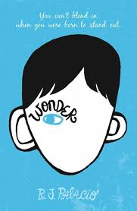
Wonder
Book Author: R.J. Palacio
Reviewed by: Saihba Virdi, 14
Star Book Reviewer of Be the Star You Are! Charity
www.bethestaryouare.org

Auggie is a 5th grader who has been home schooled his whole life, and is just now entering mainstream school for the first time. He has multiple facial deformities that make him appear different from what is socially acceptable to most people, and for that he is treated differently. The book follows his story as he navigates the complexities of middle school social dynamics, making friends and coping with bullies. He faces prejudice in many situations, and must learn to be both brave and understanding of other people.

The thing I liked about this book the most was that it was from multiple perspectives, Auggies, his sister, and even bullies, showing the humanity of the situation from all sides. It gives the reader an understanding of how people think, and how situations are often more complex than they appear on surface level. I enjoyed seeing how people were able to overcome their initial feelings of discomfort or judgement and become kinder towards others.

This is a good book for 10 year olds and above, because of social intricacies that take a bit of time to understand, otherwise, it is an emotional story with an important message. It takes a bit of time to read since it's 310 pages, and takes about 1-2 weeks to finish. It is really well written in my opinion, and I hope others enjoy it too.

