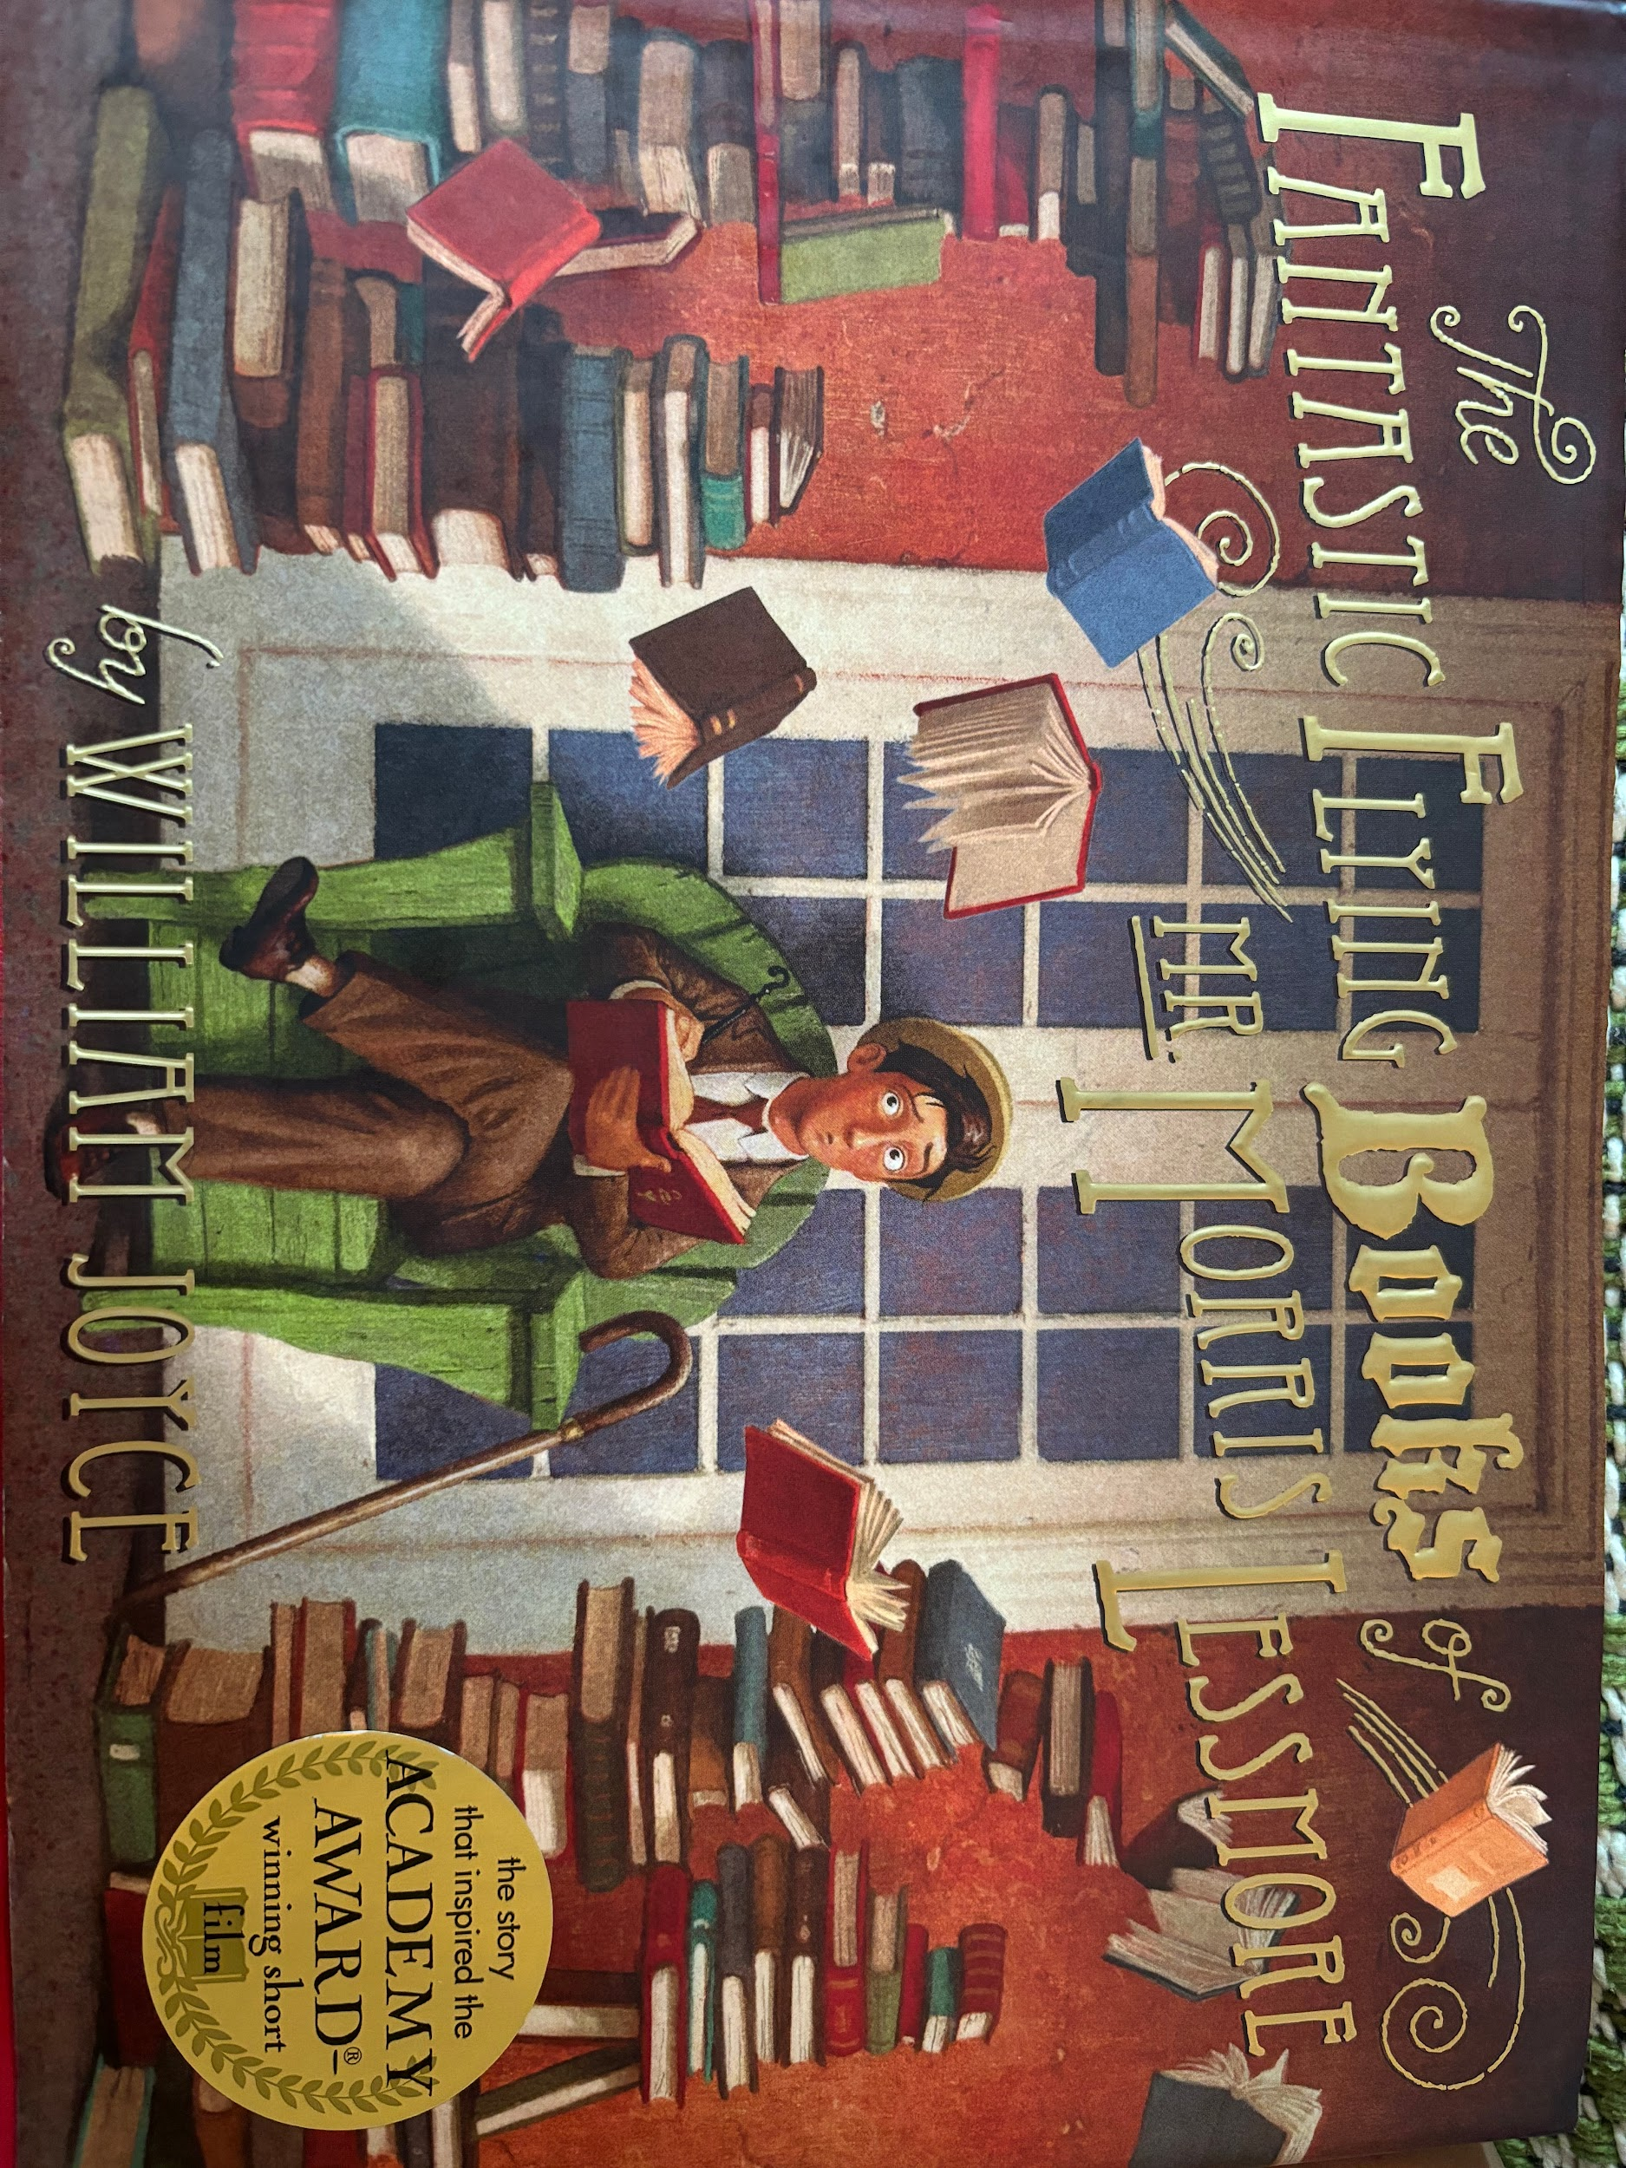
The Fantastic Flying Books of Mr. Morris Lessmore
Book Author: William Joyce
Reviewed by: Saihba Virdi, 14
Star Book Reviewer of Be the Star You Are! Charity
www.bethestaryouare.org

Mr. Morris Lessmore finds himself in a difficult situation after he loses his house in a storm. Everything he knows and loves is gone, his books scrambled and left without meaning. He is left feeling somber and confused on what to do next with his life, so he wanders around. During his wandering, he looks up, and sees a young woman flying away as she holds onto a pack of flying books. He looks up at her in wonder and wishes his books could fly as well. Almost as if the lady can hear his thoughts, she sends down a book. The book urges Mr. Morris to follow him, and leads him to a building, where the flying books live. Once he discovers this place, he embarks on an adventure to read and learn from the books. In the story, Mr. Morris Lessmore goes through his life giving others the chance to read the flying books, because he believes that others deserve to learn from the books, and give the books a chance to be heard.

William Joyce paints a world in which books have feelings, and hold stories with personal value. He enforces the idea that literacy is not only important, but enlightening, and will help people find joy in life. As life goes on, and Mr. Morris gets older, the story explores the idea of death and aging in a very understanding way. I personally liked the way they approached the topic, how they explained that he was getting older and less able, and how the books decided to start caring for him the same way he’d been caring for the books all those years. His parting from the books is bittersweet, and it symbolizes the relationships many people hold with loved ones.

The book itself is very symbolic, from the short side notes to the overarching plot, there are so many ways to interpret the story, which makes it enjoyable for almost any age group. The art is painted by the author, and is so detailed and eye-catching that I would suggest reading it just to see the artwork. In all, it is a good book for anyone 6 and older, with themes of depression and death being seen throughout the book, but it isn’t graphic, and talks about difficult themes appropriately. I suggest getting it as a gift, for its beautiful art and heartwarming story.

Recommended Titles:
-The Paper Bag princess
-The Day the Crayons Quit
-The Gruffalo
-The Boy, The Mole, The Fox, and The Horse

